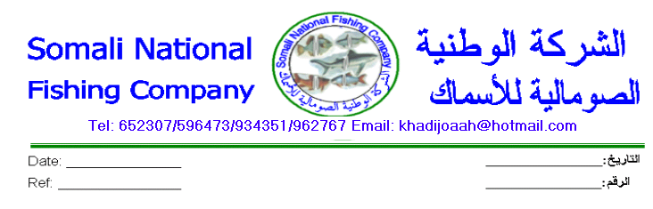

Tel: +252 615581148/615596473, Email: snfcoaah@gmail.com www.somalifish.so/new

20/03/2021

Procurement of Somali National Fishing Company boats

One of the main important factors of the Somali National Fishing Company is the resistant of the Boat build materials when Indian Ocean strong winds knock the Boats during the Fishing time.

- Specification of Volvo Boat
- 8.5m long made Fiberglass materials - one boat
- One Mator of B7/3T

- Specification of Foreport Boats
- 7m long made fiberglass boats – 4boats
- Mator 40HP made in Japan

How to Apply
Please send the quotations of these items to snfcoaah@gmail.com , not later than 31/03/2021 at 5:00 pm.
Note: make sure the email address before you send.

Shirkadda “Somali National Fishing Company” waxa ay dooneysaa in loo sameeyo Doon Volvo ah oo dhererkeedu dhan yahay 8.5 mitir balaceeduna yahay 3.5 mitir iyo 4 doomood oo dhererkoodu yahay min 7 mitir balacooduna yahay 2.5 mitir.

Waxa kale oo ay dooneysaa in loo soo gado:
- 20 bundo oo ah kuwa malayga lagu dabo.
- 15 bundo oo ah kuwa Argoostada lagu qabto.
- 400 oo biyoombe.
- 2 xarig iyo 2 baroosin oo ah kuwa Volvo yaasha lagu xiro.
- 8 xarig iyo 8 baroosin oo ah kuwa lagu xiro doomaha.
- Mator B7/3t ah.
- Mator 40 HP ah.

BN Ogeysiiskan waxa uu ku eg yahay 17 bish Appril 2021 5:00 PM.
Fadlan iska hubi e-mailka inta aadan soo dirin.

