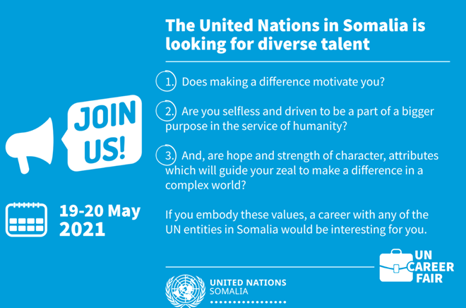
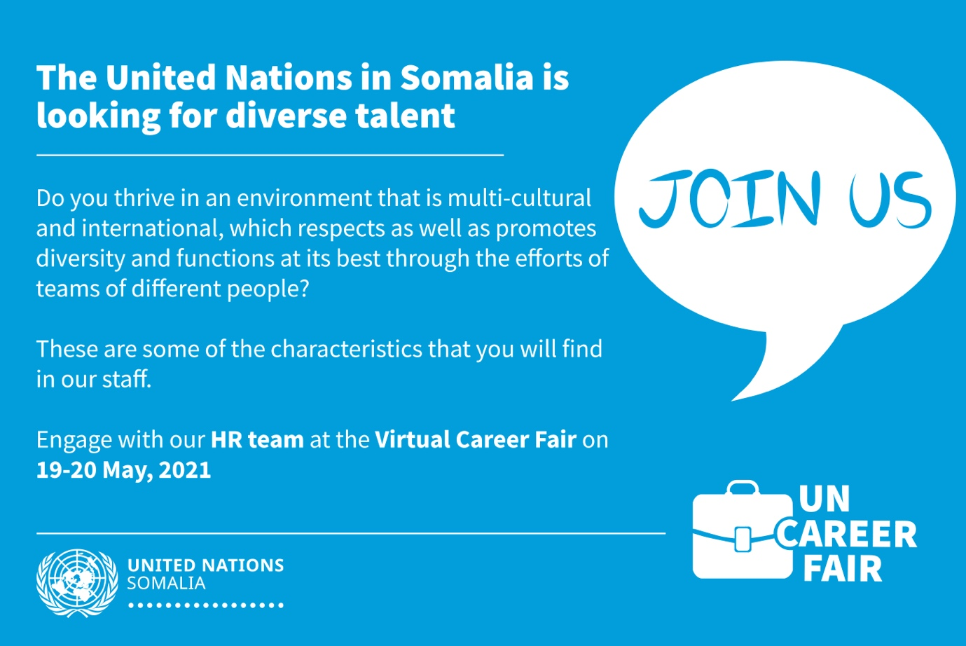

The UN Somalia Human Resources team will host a 2-day Virtual Career Fair on 19th-20th May 2021. The Fair will be an opportunity for the HR community in Somalia to create awareness of UN’s recruitment modalities, culture, shared values and competencies; and share general information that should help expand the landscape for qualified Somalis to pursue careers with the United Nations.

At the Fair, participating UN entities will share with the participants, tools, resources and other support on job opportunities and vacancy announcements, application processes and procedures, as well as general information on the UN’s interviews and selection methodologies.

To register for the Fair, please click on the links below:
- To participate in the Virtual Fair on Wednesday, May 19, 2021, 9:00 am, Eastern Africa Time, register here
- To participate in the Virtual Fair on Thursday, May 20, 2021, 9:00 am, Eastern Africa Time, register here
For More Information, please visit UNSOS website: https://unsos.unmissions.org/

